Dear All

A Summary of the Xc results from last year where we had 15 of our members selected for the team or reserves for the British & Irish Masters cross country International event (results attached) and retained our position of Inter area winners for the 2nd year running. We also had a showing at the Eastern Xc champs at Keysoe but not nearly as many as we would have liked which is something we would like to build on for next year!

Facebook post that was shared at the time, along with a photo of the trophy!

Congratulations everyone on a fantastic team performance today guys. As you can see from the photo below, we defend our title and celebrated some amazing individual performances as well. We must say a huge thanks to Maureen & Christine and the EMAC team for all the organizing and the Bury St Edmunds pacers & West Suffolk AC clubs and members for support the whole event. A great way to spend a Saturday afternoon and you can all celebrate tonight as champions!
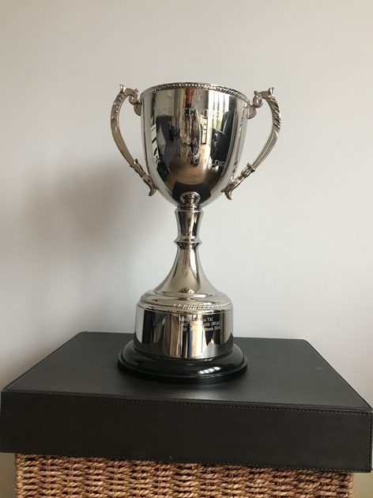``

From a Marathon point of view, we had a measure of success in the BMAF Marathon champs held in October -

Good morning All, I just wanted to share some of our fantastic results from yesterday’s BMAF Marathon championships held in York.
We had a number of Gold Medal age category winners and British Champions, take a bow - M35 David Hudson, M55 John Anderson, W40 Charlene Jacobs, W45 Toni Alcaraz!!
Janet Smith picked up the W55 Silver and I managed the M45 Bronze.
A number of the above also ran representing England as part of the England Athletics age grade championships.

Road Running Championship 2019 - Final Standings.

Yesterday's Waterside 10K brought to a close the 2019 road runners championship and over 45 of you competed in at least one race across the year and hopefully enjoyed taking part. We witnessed some fantastic performances across the season, the highest age grading being Paul Mingay’s 93.6% at the Fenland 10. The overall championship is an average of your best three age graded performance's across the season - so you need to be in it, to win it!!
Chris Cooke is 2019's overall winner with an outstanding overall average of 90.2% - an amazing result across the season. Well done Chris and you will be awarded your trophy at this year’s AGM! Jane Ashby also had a fantastic season and finished as runner up with 87.96% (best 3 from 4). I managed to just stay ahead of fellow club mate Rod McKee on 81.24% who achieved a string of PB's to close another fantastic year of running. Pauline Stocker 5th on 75.04% - Matthew Mason, 6th 67.46% and Keith Morris 7th - 60.03%.
Next years campaign will grow to 7 races, with the best 4 to count - adding the Peterborough Marathon on April 5th and a 5k race (TBC) to suit all EMAC members.
The entries for Peterborough are already open – it’s a great race and I can highly recommend it.

